**Chapter – 5**

**SCREEN SHOTS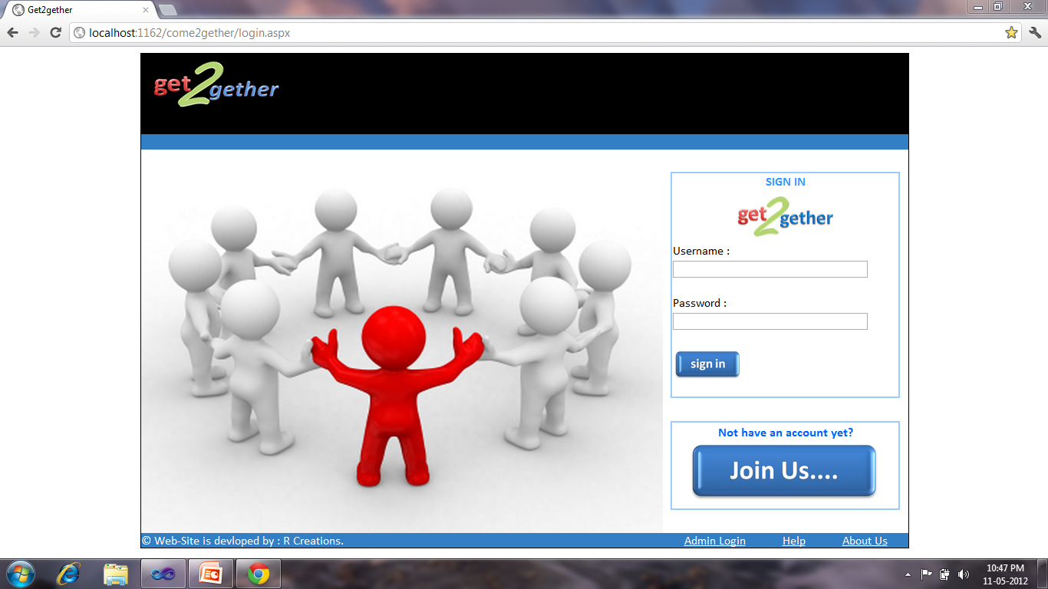**Fig-15 Login Screen

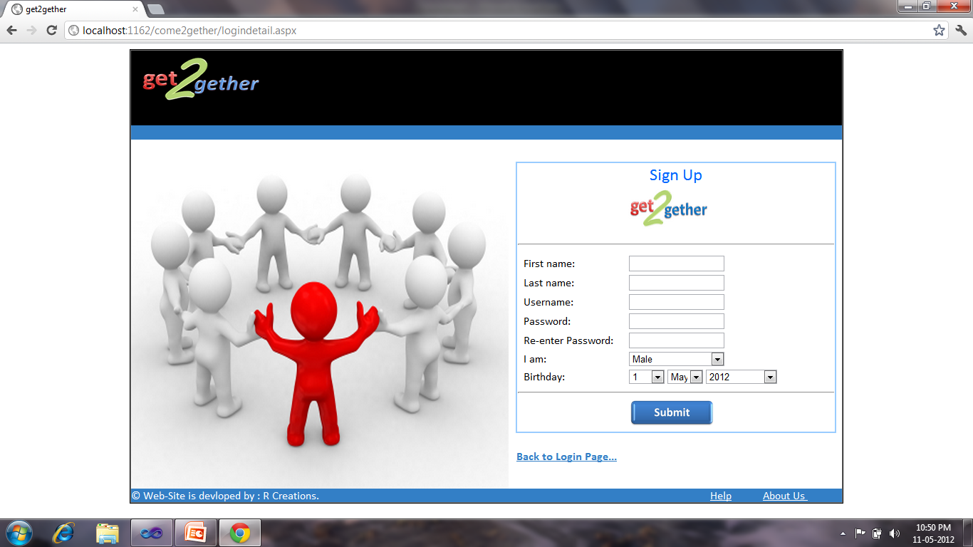

Fig- 16 Join Us Account Creation

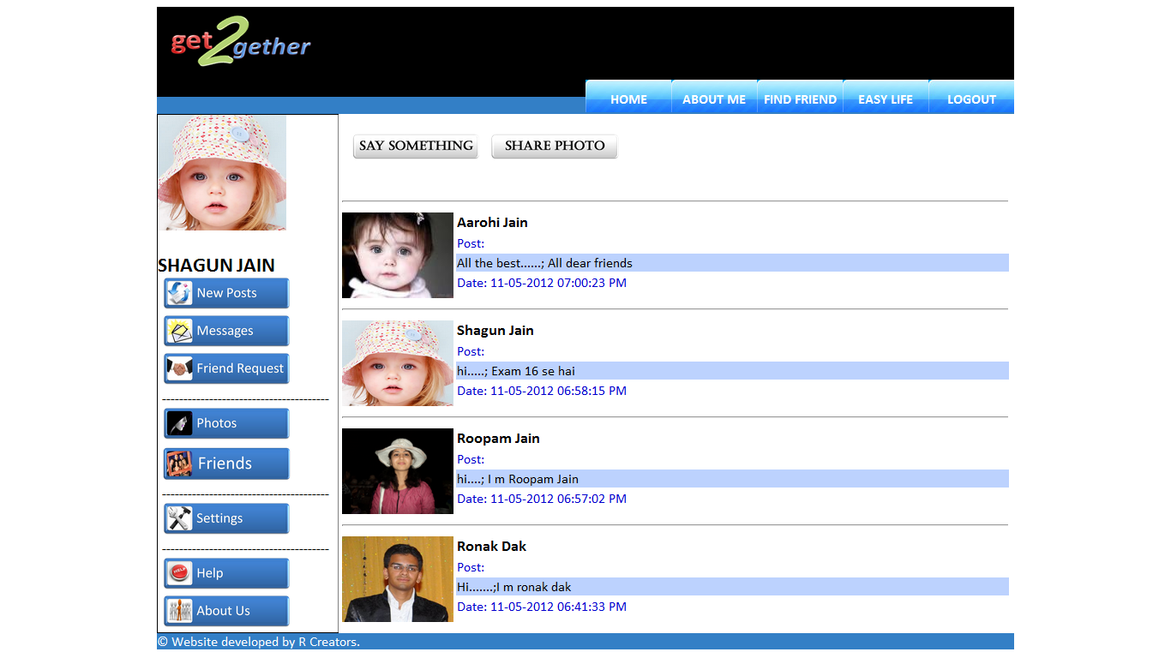

Fig- 17 Home/New Post page

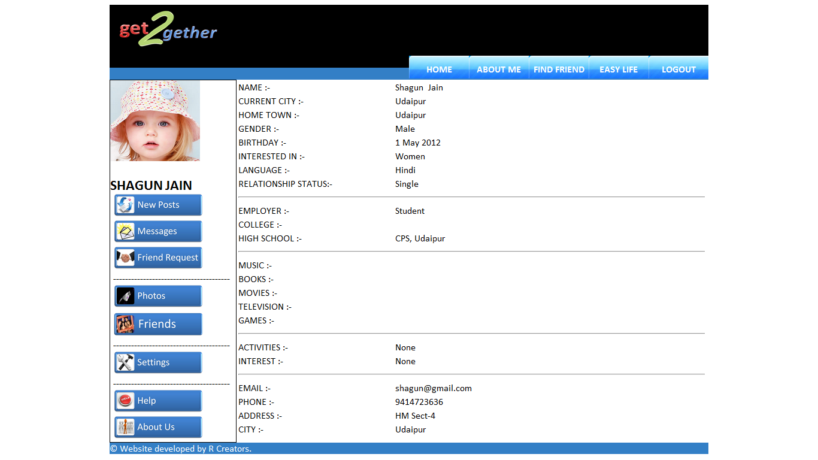Fig- 18 About Me

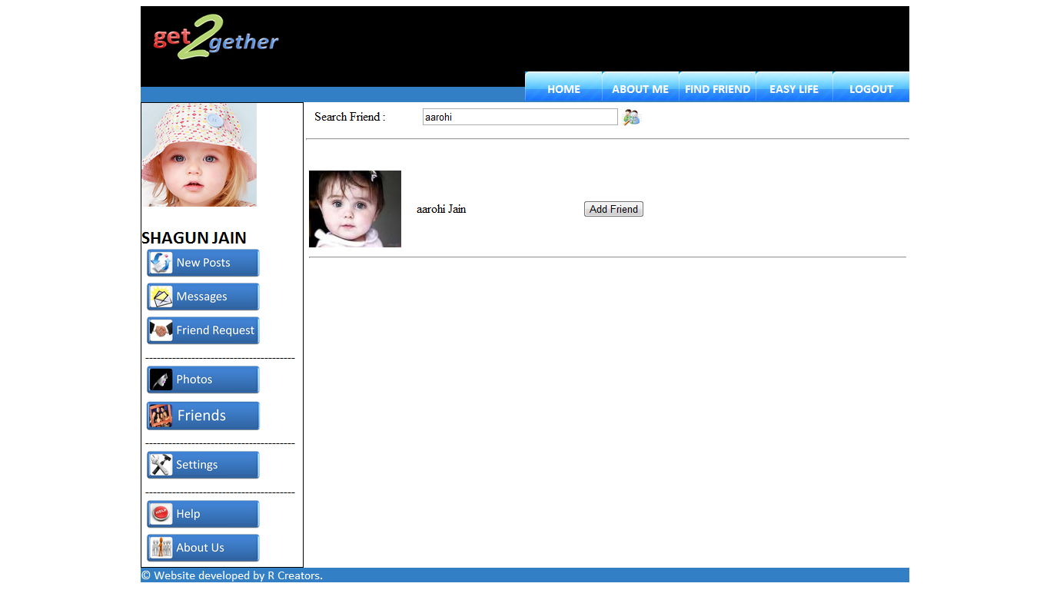

Fig- 19 Find Friend

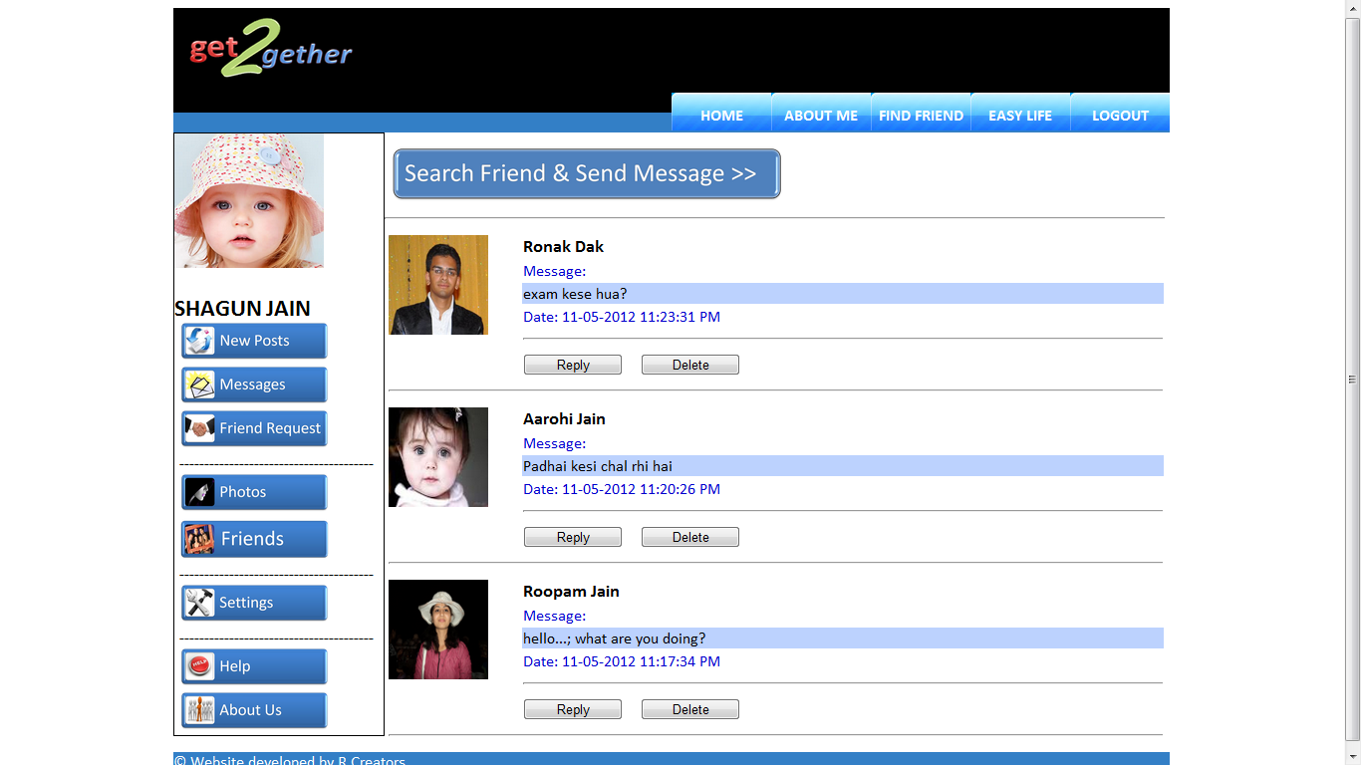

Fig- 20 Messages

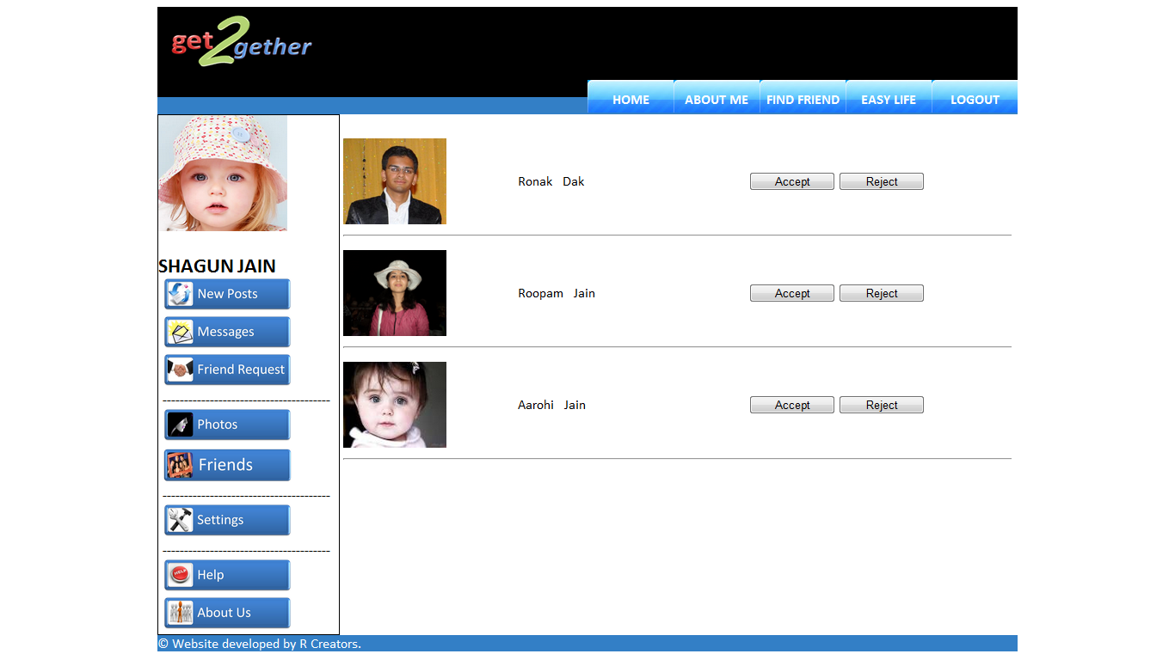

Fig- 21 Friend Request

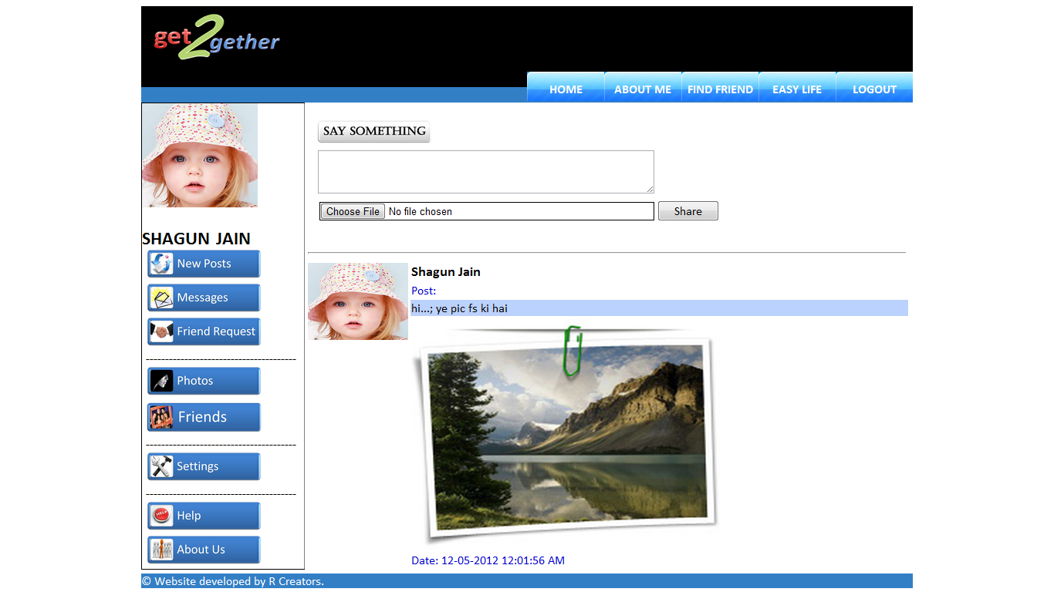

Fig- 22 Share Images/Pictures

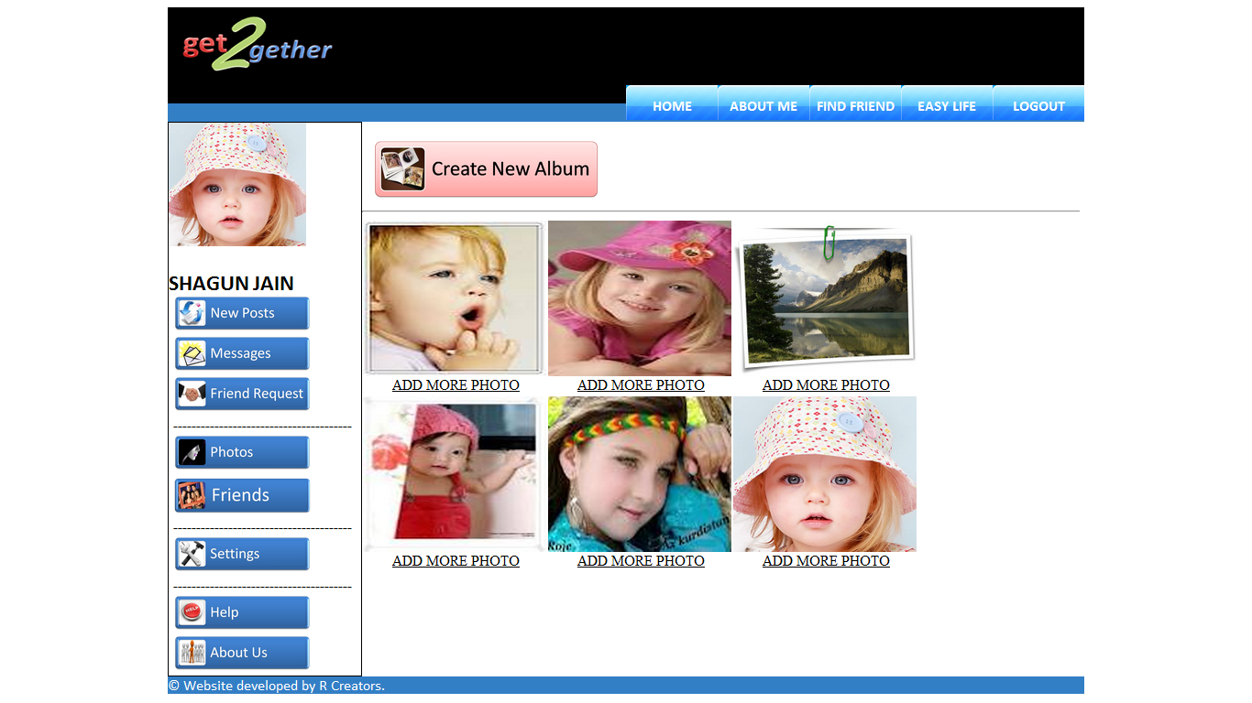

Fig- 23 Albums(Photos)

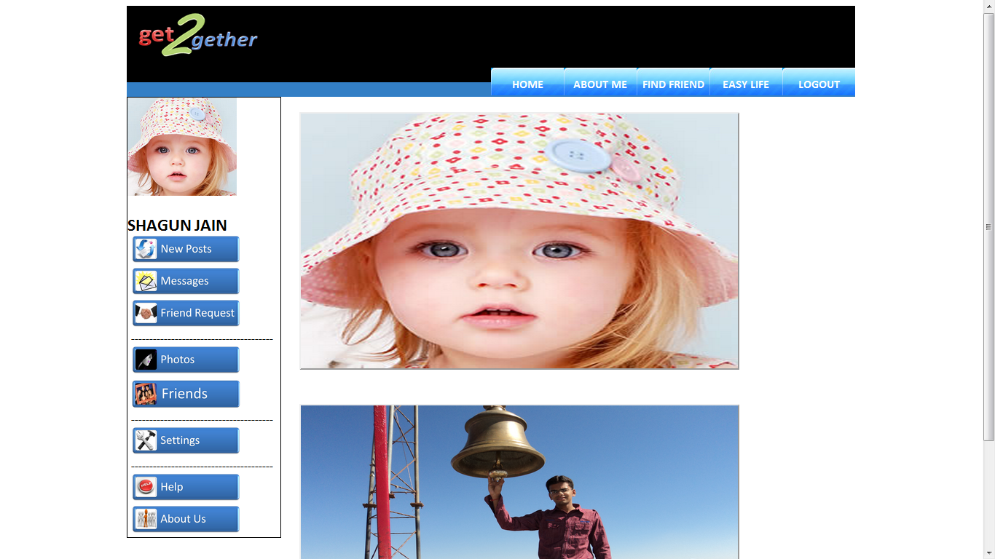

Fig- 24 Photos

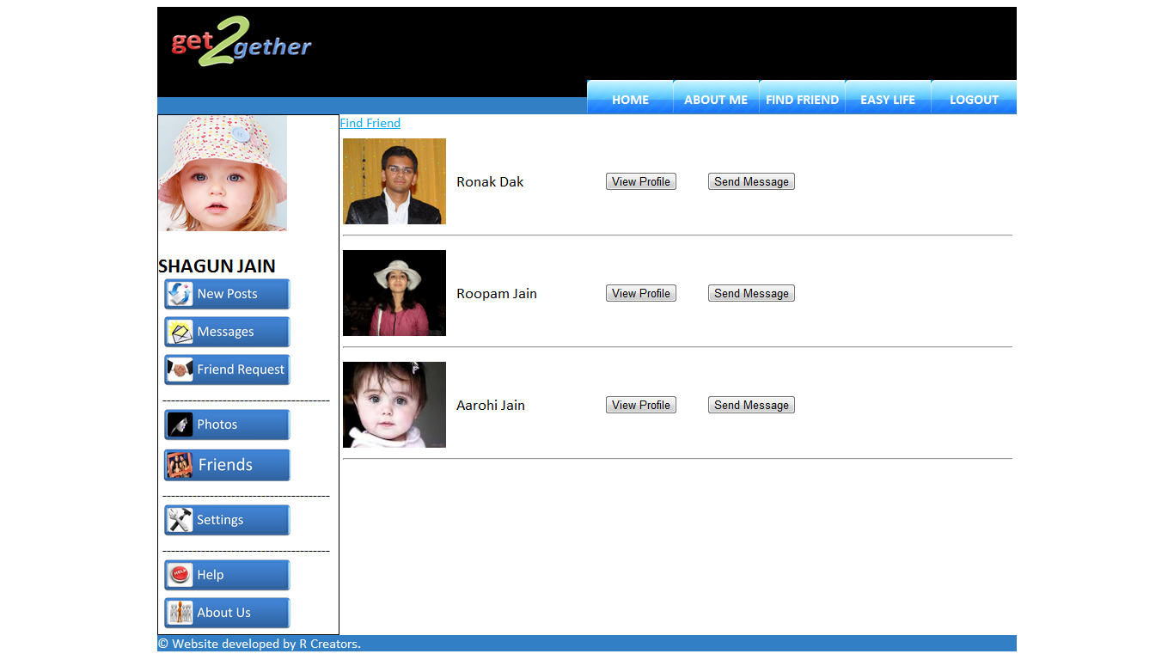

Fig- 25 Friends

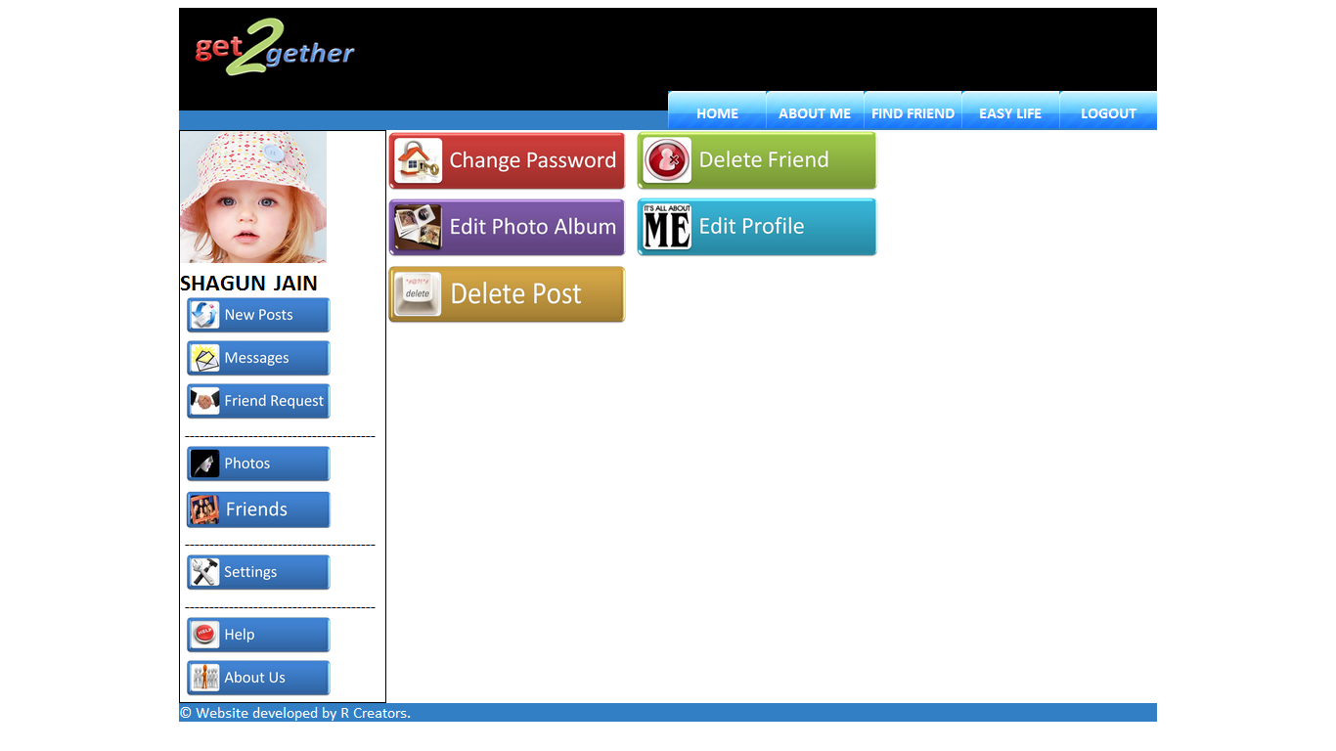

Fig- 26 Settings Page

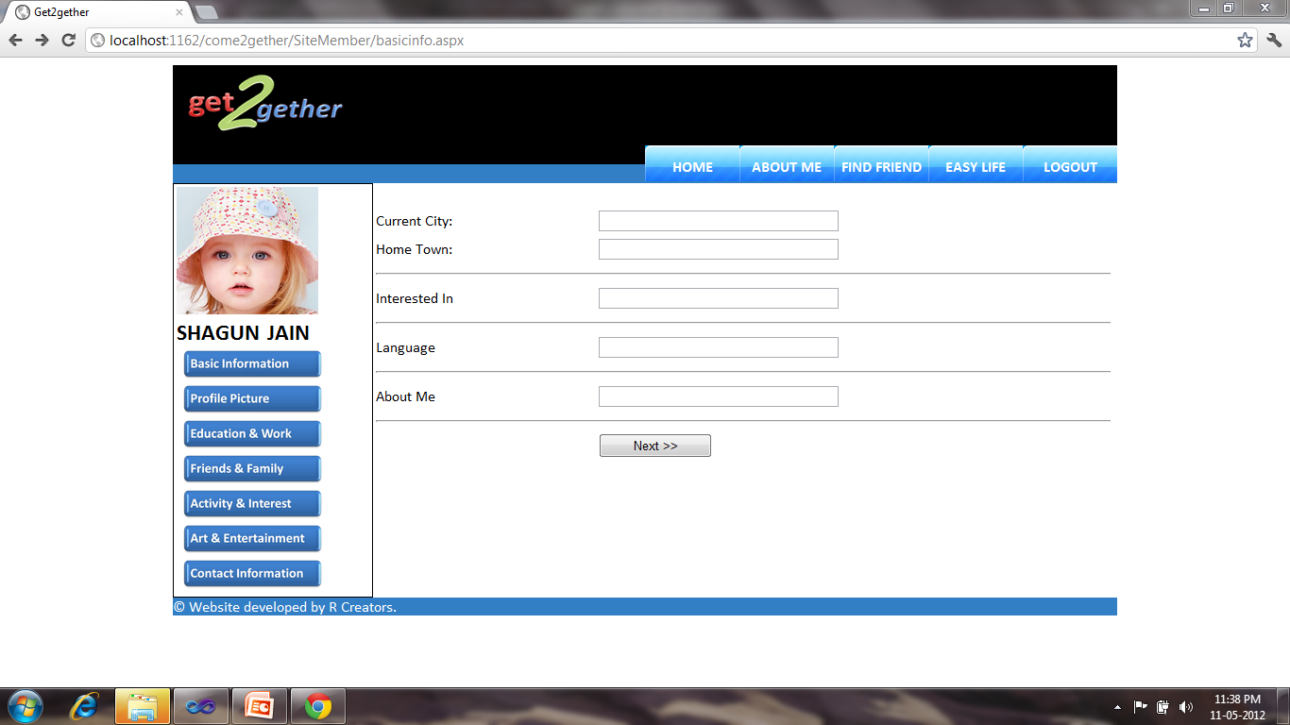

Fig- 27 Edit Profile (Basic Information)

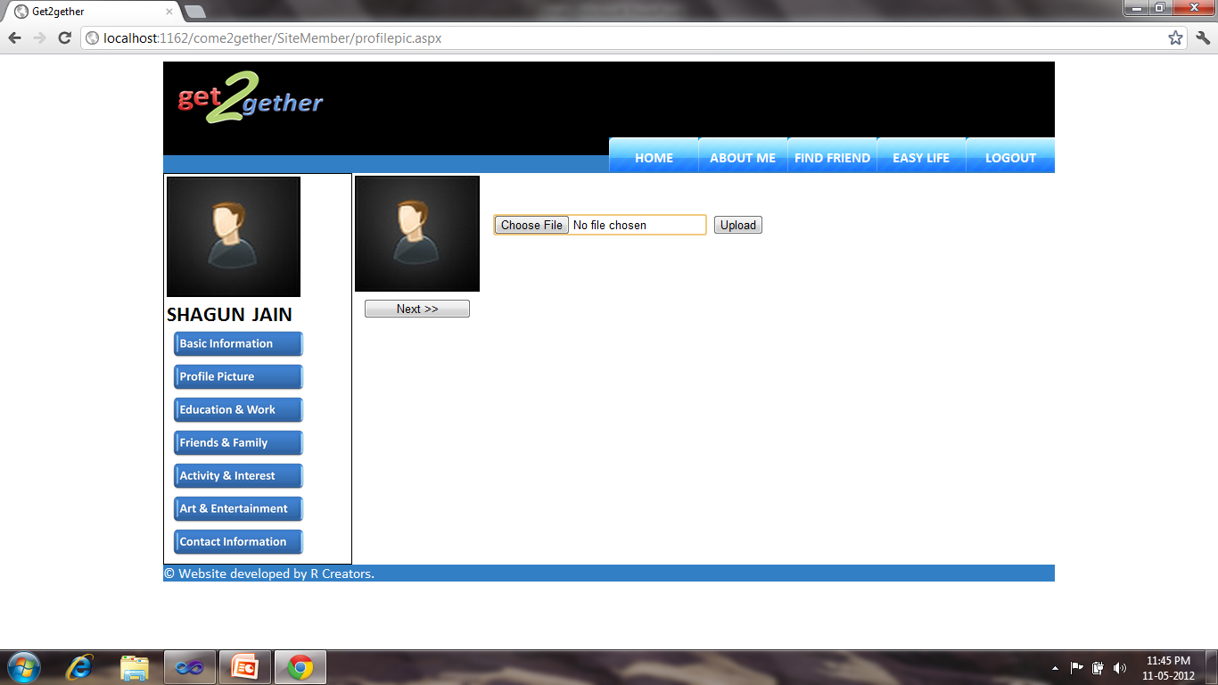

Fig- 28 Edit Profile (Profile Picture)

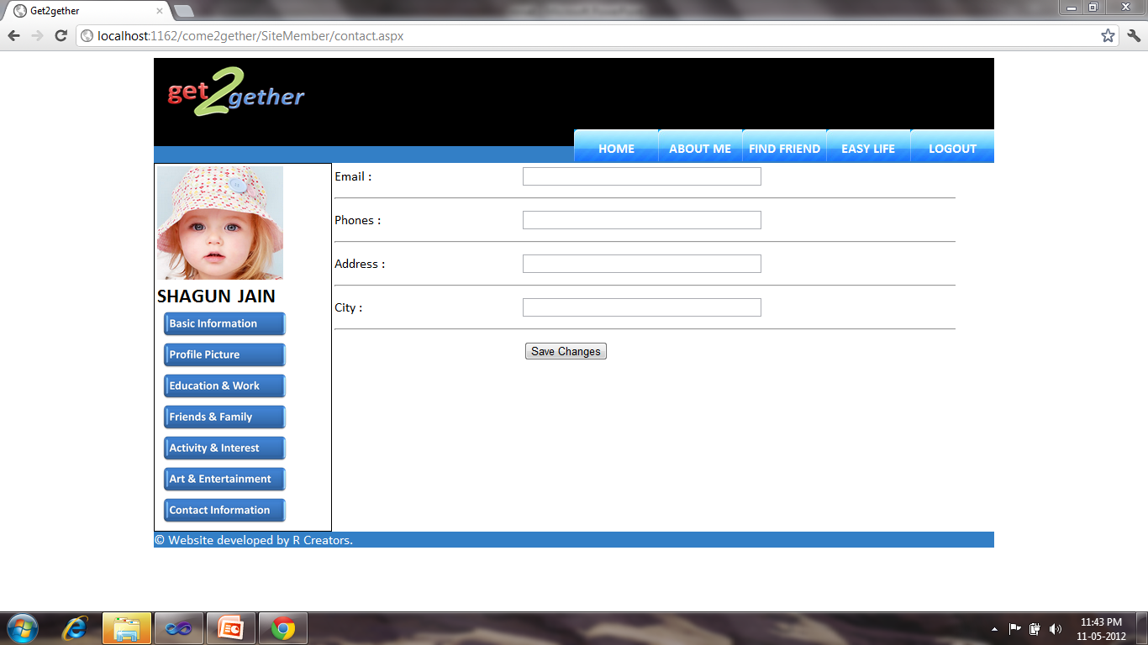

Fig- 29 Edit Profile (Contact)

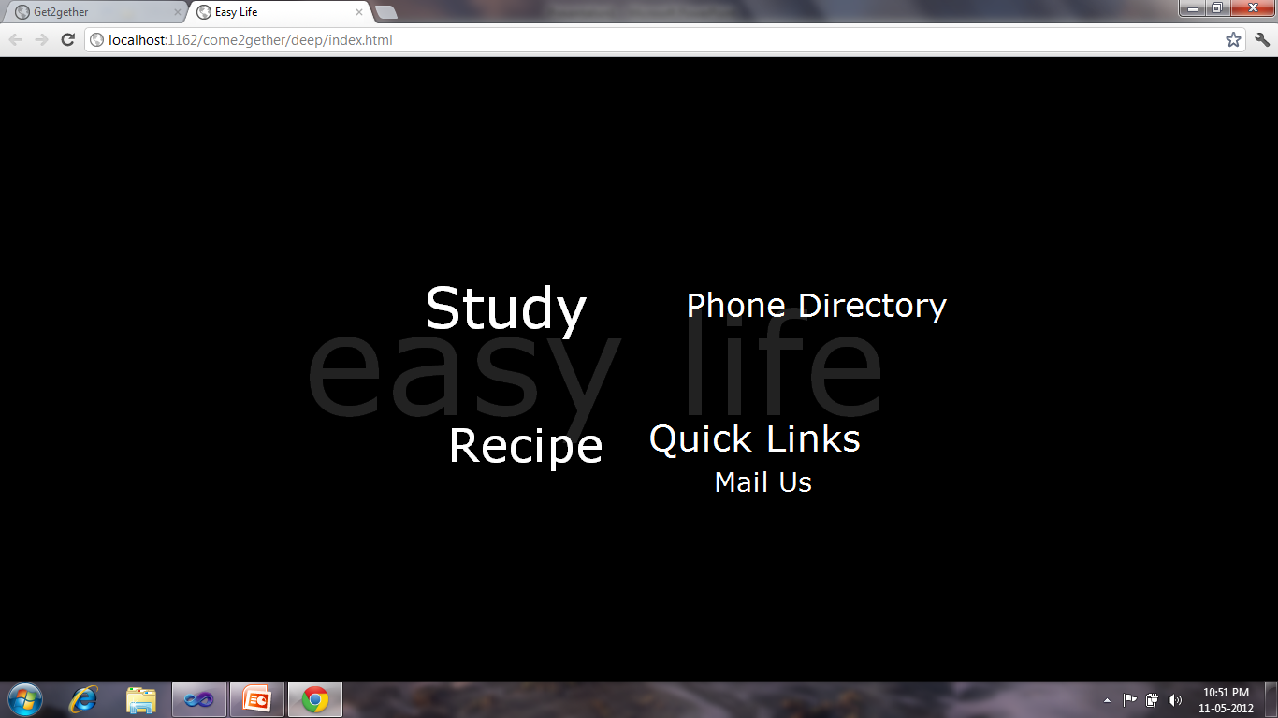

Fig- 30 Easy Life

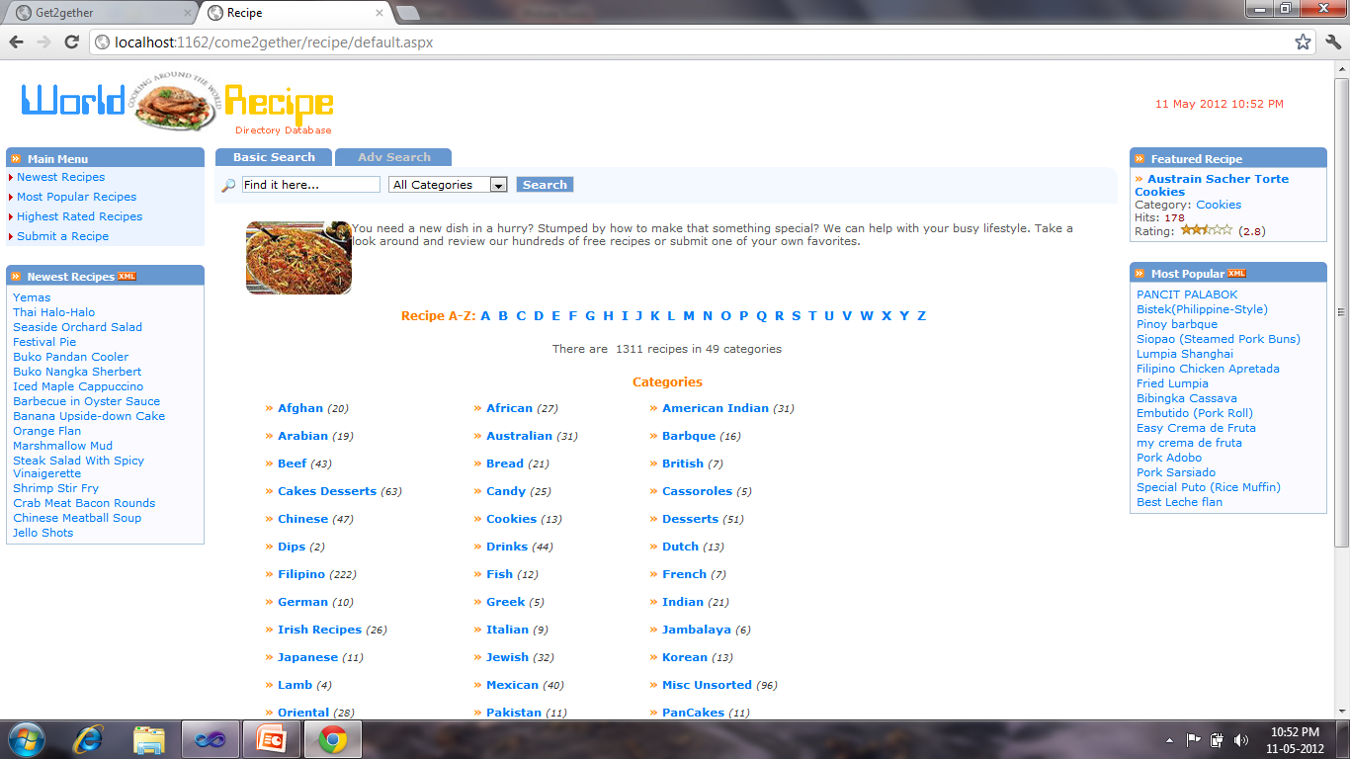

Fig- 31 Recipe (Easy Life)

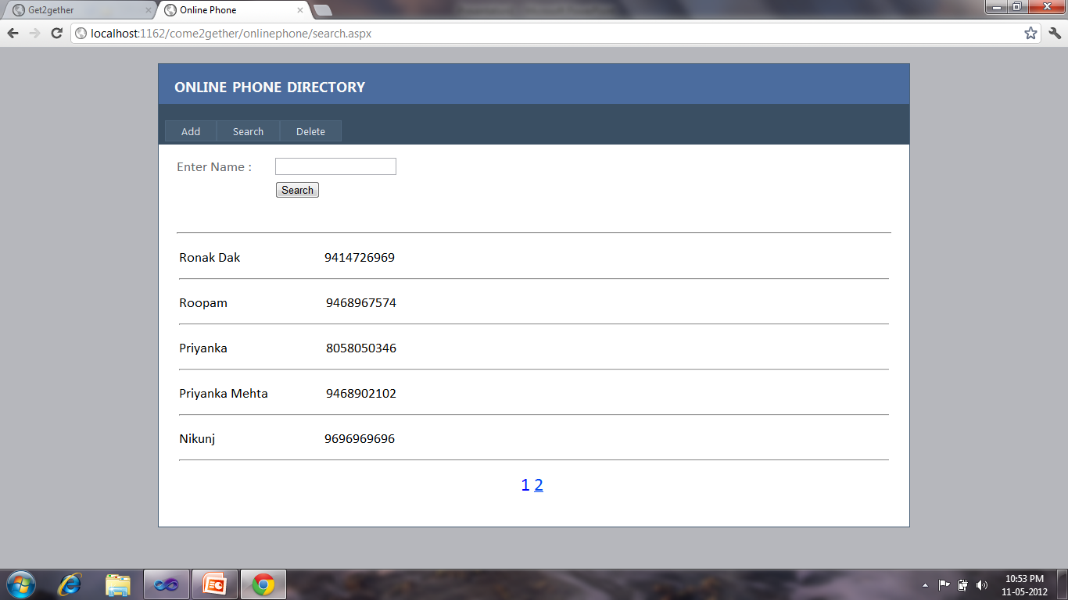

Fig- 32 Phone Directory (Easy Life)

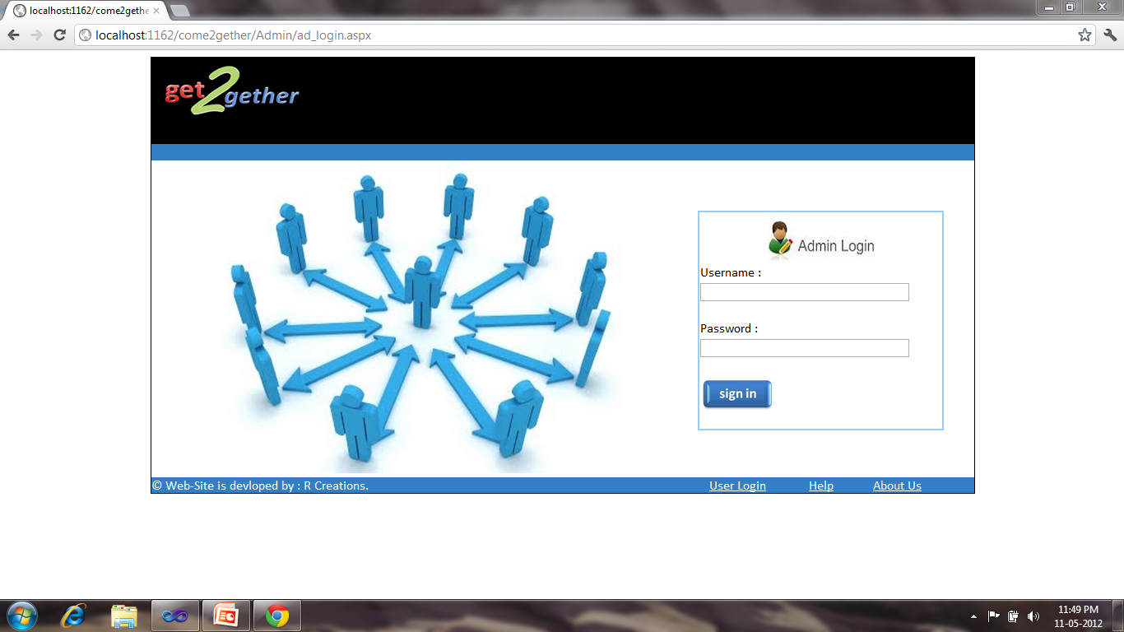

Fig- 33 Admin Login

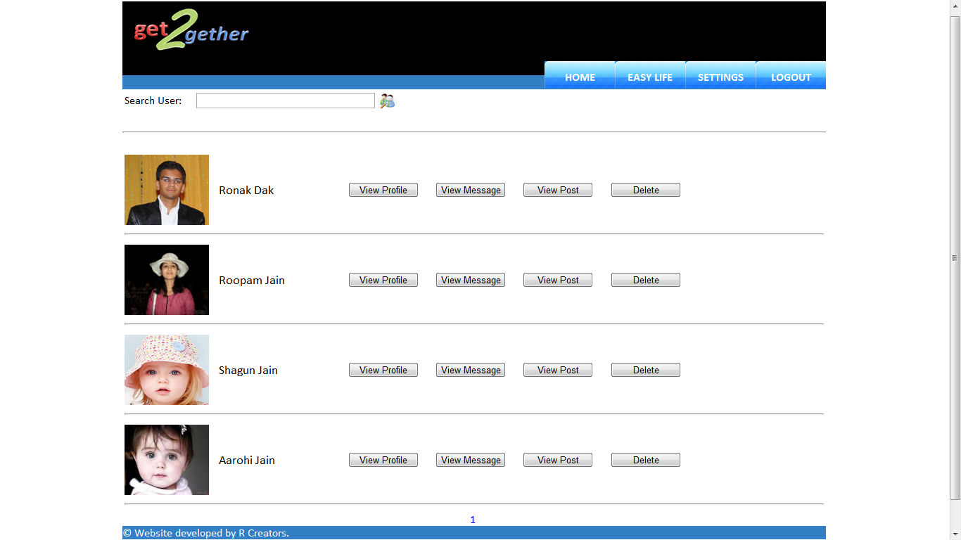

Fig- 34 Admin Home